JUnit Testing Exercises
Exercise 1: Setting Up JUnit
Scenario:
You need to set up JUnit in your Java project to start writing unit tests.
Steps:
1. Create a new Java project in your IDE (e.g., IntelliJ IDEA, Eclipse).
2. Add JUnit dependency to your project. If you are using Maven, add the following to your
pom.xml:
<dependency>
<groupId>junit</groupId>
<artifactId>junit</artifactId>
<version>4.13.2</version>
<scope>test</scope>
</dependency>
3. Create a new test class in your project.

Code :
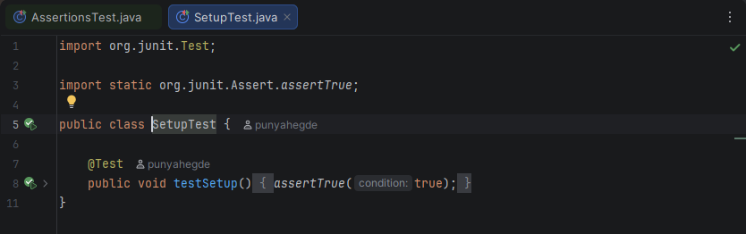

Output :
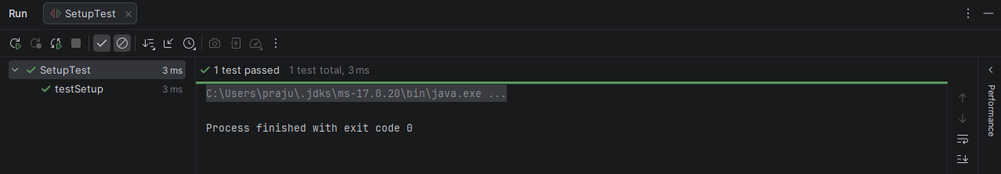

Exercise 3: Assertions in JUnit
Scenario:
You need to use different assertions in JUnit to validate your test results.
Steps:
1. Write tests using various JUnit assertions.
Solution Code:
public class AssertionsTest {
@Test
public void testAssertions() {
// Assert equals
assertEquals(5, 2 + 3);
// Assert true
assertTrue(5 > 3);
// Assert false
assertFalse(5 < 3);
// Assert null
assertNull(null);
// Assert not null
assertNotNull(new Object());
}
}

Code :
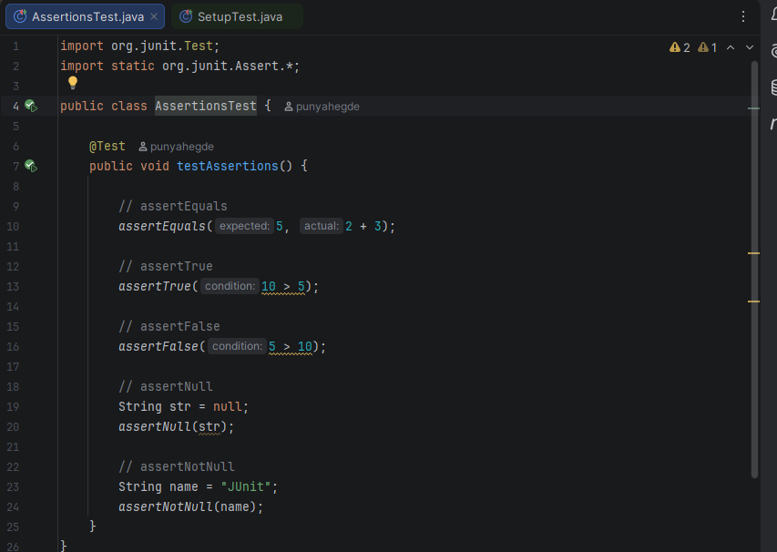

Output :
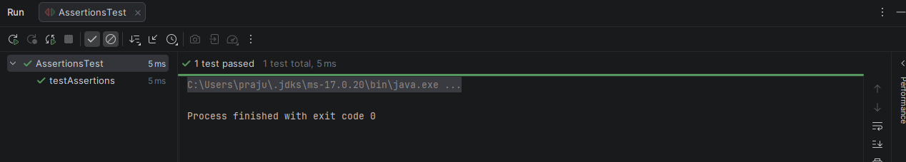

Exercise 4: Arrange-Act-Assert (AAA) Pattern, Test Fixtures, Setup and
Teardown Methods in JUnit
Scenario:
You need to organize your tests using the Arrange-Act-Assert (AAA) pattern and use setup
and teardown methods.
Steps:
1. Write tests using the AAA pattern.
2. Use @Before and @After annotations for setup and teardown methods.

Code :
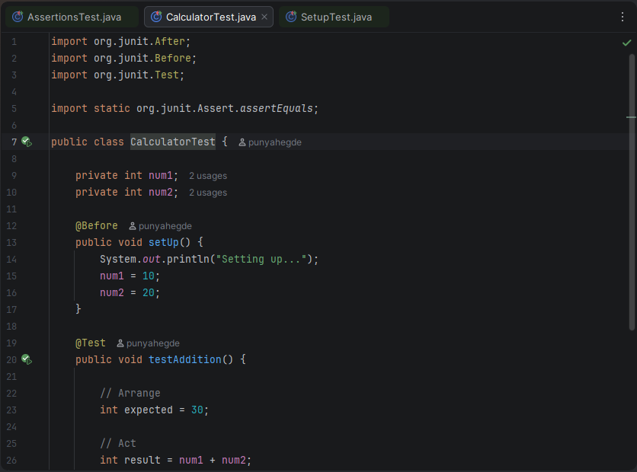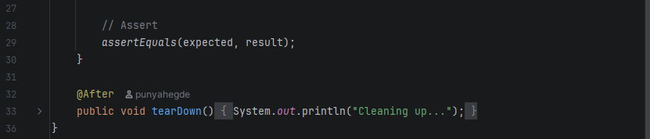
Output :
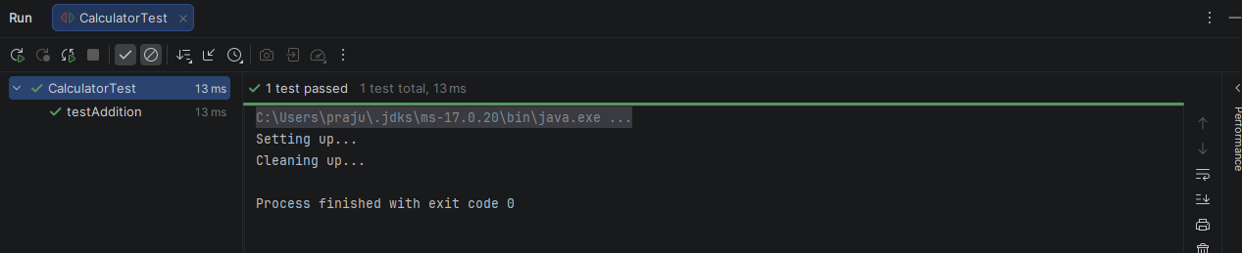
Exercise 1: Mocking and Stubbing
Scenario:
You need to test a service that depends on an external API. Use Mockito to mock the
external API and stub its methods.
Steps:
1. Create a mock object for the external API.
2. Stub the methods to return predefined values.
3. Write a test case that uses the mock object.
Solution Code:
import static org.mockito.Mockito.*;
import org.junit.jupiter.api.Test;
import org.mockito.Mockito;
public class MyServiceTest {
@Test
public void testExternalApi() {
ExternalApi mockApi = Mockito.mock(ExternalApi.class);
when(mockApi.getData()).thenReturn("Mock Data");
MyService service = new MyService(mockApi);
String result = service.fetchData();
assertEquals("Mock Data", result);
}
}

Code :
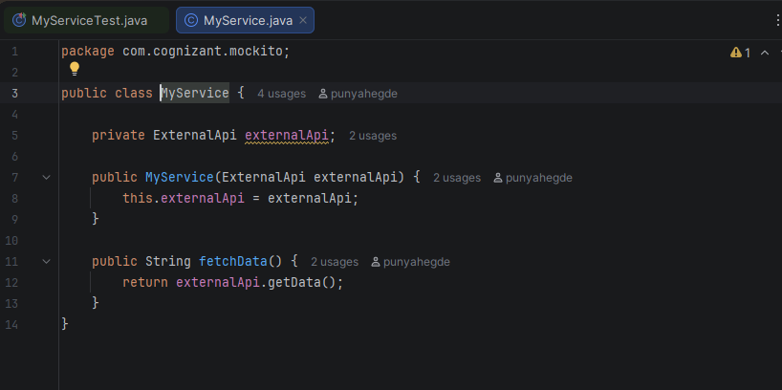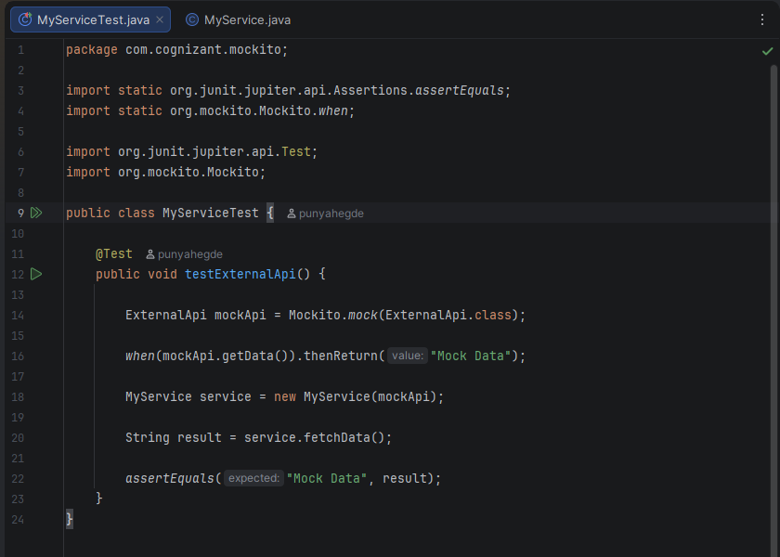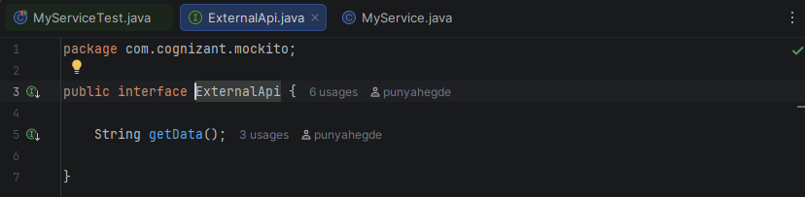
Output :
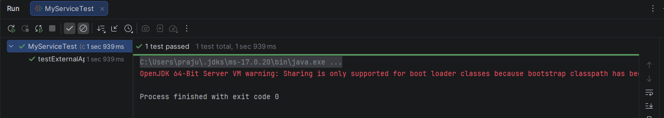

Exercise 2: Verifying Interactions
Scenario:
You need to ensure that a method is called with specific arguments.
Steps:
1. Create a mock object.
2. Call the method with specific arguments.
3. Verify the interaction.
Solution Code:
import static org.mockito.Mockito.*;
import org.junit.jupiter.api.Test;
import org.mockito.Mockito;
public class MyServiceTest {
@Test
public void testVerifyInteraction() {
ExternalApi mockApi = Mockito.mock(ExternalApi.class);
MyService service = new MyService(mockApi);
service.fetchData();
verify(mockApi).getData();
}
}
Exercise 3: Ar

Code :
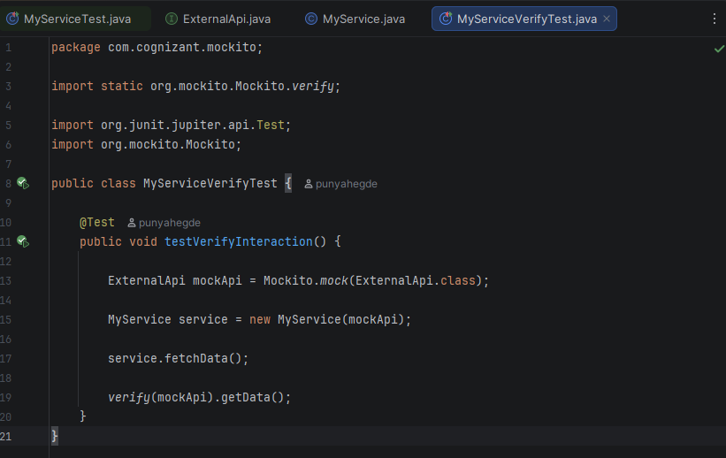


Output :
